UNITED STATES
SECURITIES AND EXCHANGE COMMISSION
Washington, D.C. 20549

SCHEDULE 14A
PROXY STATEMENT PURSUANT TO SECTION 14(a) OF THE
SECURITIES EXCHANGE ACT OF 1934

Filed by the Registrant ☒
Filed by a party other than the Registrant ☐
Check the appropriate box:

☐ | Preliminary Proxy Statement

☐ | Confidential, for Use of the Commission Only (as permitted by Rule 14a-6(e)(2))

☐ | Definitive Proxy Statement

☒ | Definitive Additional Materials

☐ | Soliciting Material Under §240.14a-12
LIVEPERSON, INC.
(Name of Registrant as Specified In Its Charter)
(Name of Person(s) Filing Proxy Statement, if other than the Registrant)
Payment of Filing Fee (Check all boxes that apply):

☒ | No fee required

☐ | Fee paid previously with preliminary materials

☐ | Fee computed on the table in exhibit required by Item 25(b) per Exchange Act Rules 14a-6(i)(1) and 0-11

On August 10, 2026, LivePerson, Inc. sent the following message regarding its 2026 special meeting to shareholders with Robinhood accounts via Say Technologies, LLC’s shareholder communication platform:

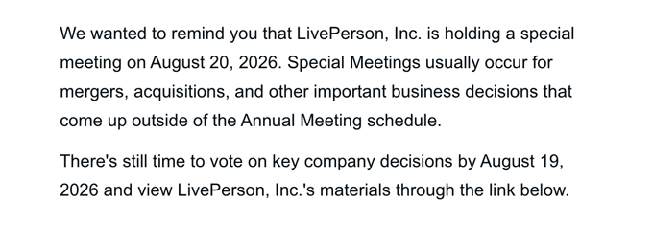
We wanted to remind you that LivePerson, Inc. is holding a special meeting on August 20, 2026. Special Meetings usually occur for mergers, acquisitions, and other important business decisions that come up outside of the Annual Meeting schedule. There’s still time to vote on key company decisions by August 19, 2026 and- view LivePerson, lnc ‘s materials through the link below.

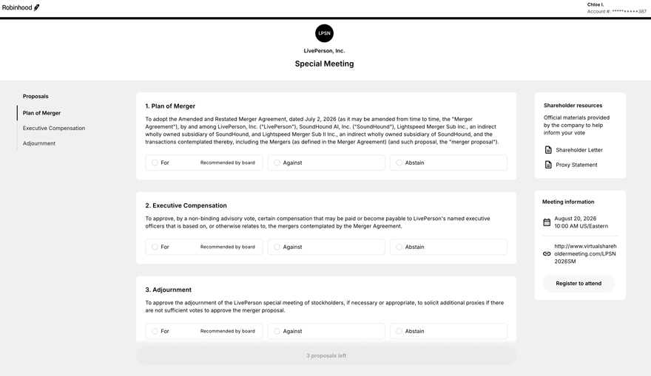
f Chloe I. Robinhood Account#: **********387  LivePerson, Inc. Special Meeting Proposals 1. Plan of Merger Shareholder resources Plan of Merger To adopt the Amended and Restated Merger Agreement, dated July 2, 2026 (as it may be amended from time to time, the “Merger Official materials provided Agreement”), by and among LivePerson, Inc. (“LivePerson”), SoundHound Al, Inc. (“SoundHound”), Lightspeed Merger Sub Inc., an indirect by the company to help Executive Compensation wholly owned subsidiary of SoundHound, and Lightspeed Merger Sub II Inc., an indirect wholly owned subsidiary of SoundHound, and the inform your vote Adjournment transactions contemplated thereby, including the Mergers (as defined in the Merger Agreement) (and such proposal, the “merger proposal”). (El Shareholder Letter For Recommended by board Against Abstain (El Proxy Statement 2. Executive Compensation Meeting information To approve, by a non-binding advisory vote, certain compensation that may be paid or become payable to LivePerson’s named executive August 20, 2026 El l!!::I officers that is based on, or otherwise relates to, the mergers contemplated by the Merger Agreement. 10:00 AM US/Eastern For Recommended by board Against Abstain http://www .virtualshareh c-:::> oldermeeting.com/LPSN 2026SM Register to attend 3. Adjournment To approve the adjournment of the LivePerson special meeting of stockholders, if necessary or appropriate, to solicit additional proxies if there are not sufficient votes to approve the merger proposal. For Recommended by board Against Abstain 3 proposals left

